@Controller annotation then view must

Be normal html, jsp or thymeleaf or any java view technologies.

Amazon 🡪 Spring boot

Payment --🡪 paypal --🡪 Java

Paytm -🡪Python

Gpay -🡪 php

Phone pay -🡪.net

Net banking

Credit card

Web Service : Giving the service for web application when both application running using same or different technologies.

1. SOAP Web Service : Simple Object Access Protocol. In SOAP web service we can consume and produce the data in the form of XML.(eXtensible markup of language).

SOAP web service depends up SOA (Service oriented architecture).

1. Rest full web service : In Rest full web service we can consume and produce the data in any format base upon client requirement. Like xml, json, text, html any media type etc

Representation State Transfer : using rest api we can expose our resources servlet, jsp, spring controller as web service.

@Controller annotation view must be java

@RestController annotation then view can be java, php, python, angular or react etc any rest client.

Creating simple rest api

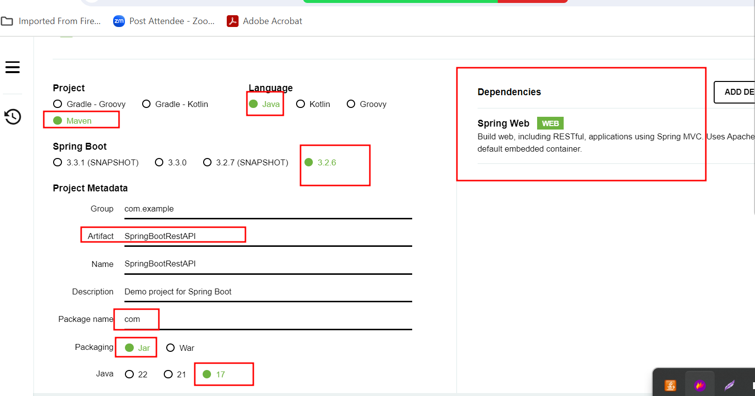

Rest API endpoint

1. Get method : return type string in plain text format, html format, xml format.
2. Get method : return type user defined class object in the form of json.
3. Get method : if we want to pass any value to rest api
   1. Query param

url?key=value if we want to pass single value

url?key=value&key=value if we want to pass multiple value

by default html form with get method internally use query param technique.

* 1. Path param

url/value1 if we want to pass single value

url/value1/value2/value3 if we want to pass multiple value.

Post method :

1. Post method is use to store the data in database.

Sending the data using post man client with post method

First we need to set header property as contentType application/json

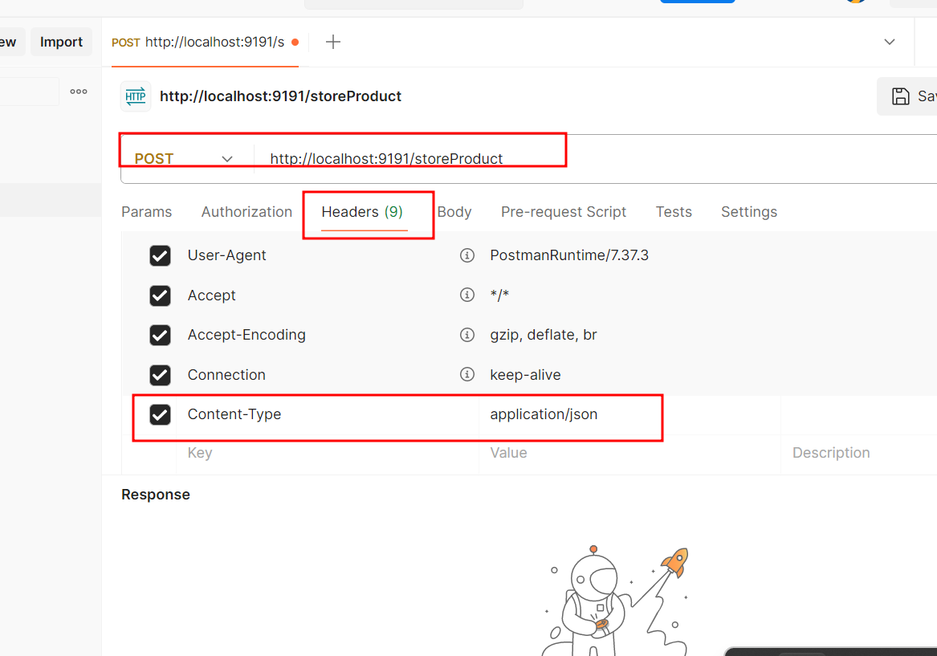

Body option

